Description: Military Hidden Human Dataset (HuCOD)
1. Dataset Motivation
Existing COD benchmarks mainly contains animals, insects, underwater objects, and general camouflage scenes
Examples: COD10K, CAMO, Chameleon, NC4K
However, military camouflage presents additional challenges:
- human-shaped targets
- tactical concealment
- woodland/desert/urban environments
- partial body visibility
- soldier uniforms matching background texture
- long-range observation conditions
Military camouflage datasets remain limited compared with general COD datasets. Recent studies also highlight the scarcity of military-specific camouflage data and the need for dedicated datasets containing camouflaged humans and military objects. Therefore, HuCOD was constructed to provide a focused benchmark for human-centric military camouflage object detection.
2. Dataset Sources
Source Category | Description
Public COD datasets | COD10K, CAMO, Chameleon, NC4K, ACD1K
Internet sources | Google
3. Dataset Composition
Category | Count
Total images | 64+11 + 143 + 1071 + 387 + 33 = 1709
Military camouflage images | 11 + 143 + 907 + 387 + 33 = 1481
Non-military camouflage images | 64 + 164 = 228
Training images | 64+11 + 143 + 1071 = 1289
Validation images | 0
Test images (25%) | 387 + 33 = 420
Annotation type | Binary masks
Image sources | Public datasets + public web images
Resolution | Variable

4. Annotation Process
Annotation Type
Binary segmentation masks:
- foreground:
  - hidden/camouflaged human
- background:
  - environment
"Each image compiled from original sources and used as with same annotation. Internet source images where annotated only based on manual boundary marking."
Annotation Procedure
Initial annotations were generated manually using image annotation tools. Each mask was visually inspected to ensure accurate object boundaries, particularly for challenging cases involving partial visibility, occlusion, and low contrast between human targets and surrounding environments.
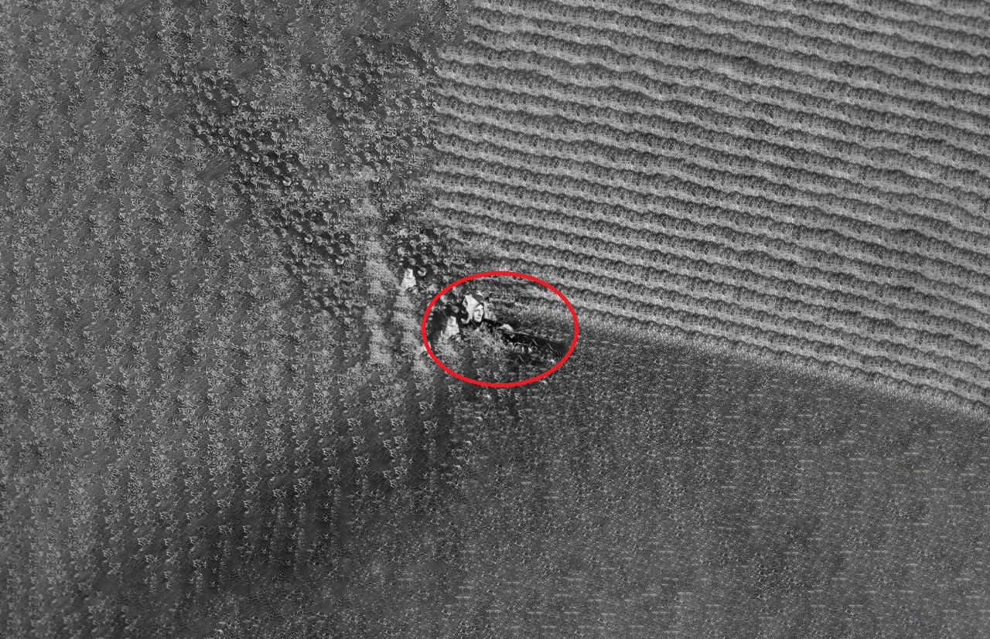
5. Quality Control
Inclusion criteria Images were selected if:
- human subject was visually identifiable
- camouflage pattern existed
- environmental concealment existed
- sufficient resolution was available
- foreground/background separation was possible
Exclusion criteria Images removed:
- duplicate images
- corrupted files
- extremely low-resolution images
- images without visible human camouflage
- images already appearing in benchmark COD datasets
6. Overlap Checking with Existing Benchmarks
Followed as per benchmark datasets did, however, internet sourced were compared and no duplication were found.
7. Dataset Split Strategy
The dataset was divided at image level to avoid information leakage between training and testing subsets. Images originating from the same sequence/source were maintained within the same split whenever possible.
8. Licensing Statement
HuCOD is released for academic research and benchmarking purposes. The dataset contains images collected from publicly available sources. Copyright ownership remains with the original content providers. Users are responsible for complying with the original source licenses and usage restrictions.
9. Suggested Dataset Card for GitHub
https://github.com/KShaz/Human-Military-COD-Dataset/tree/main
10. Add Statistics File
https://drive.google.com/drive/folders/1-pSfTflvmhU6yxOL8Yc_migNm_u7aAWu?usp=drive_link

Parameter | Value
Total Images | 1709
Classes | 1
Object Type | Human
Annotation Type | Binary Mask (as per benchmark)
Sources | Multiple Public Sources
Train Images | 1289
Validation Images | 0
Test Images | 420
Duplicate Removed | Yes
Human Verification | Yes
11. Paper Section Placement
Placed under dataset section
11. Weights
Placed under dataset section
https://drive.google.com/drive/folders
/1PECpPIAnPORlytwMXULD2y86jpfXhqjf?usp=drive_link

